**St. Albans School and the Promus**

**The following post was written by our intern, Kaitlin Scott. Kaitlin is a student of the University of South Carolina’s School of Library and Information Science. She has recently completed digitizing our collection of yearbooks for the St. Alban’s School for Boys. Visit the collection here,**[**the Promus**](http://monk.radford.edu/cdm/landingpage/collection/promus)**.**

St. Albans School for Boys was founded in 1892 by George W. Miles, who served as headmaster of the School. Miles founded the school after ten years as a professor at Emory and Henry College at the age of 30. Built to accommodate 50 boys in order to prepare them for university or business, the school was founded on the premise that boys have an educational home away from the temptations and distractions of a city. St. Albans buildings were built in the colonial style with wide verandas, white columns and classic gables as can be seen from a photo taken from the 1893-1894 issue of the *Promus*.

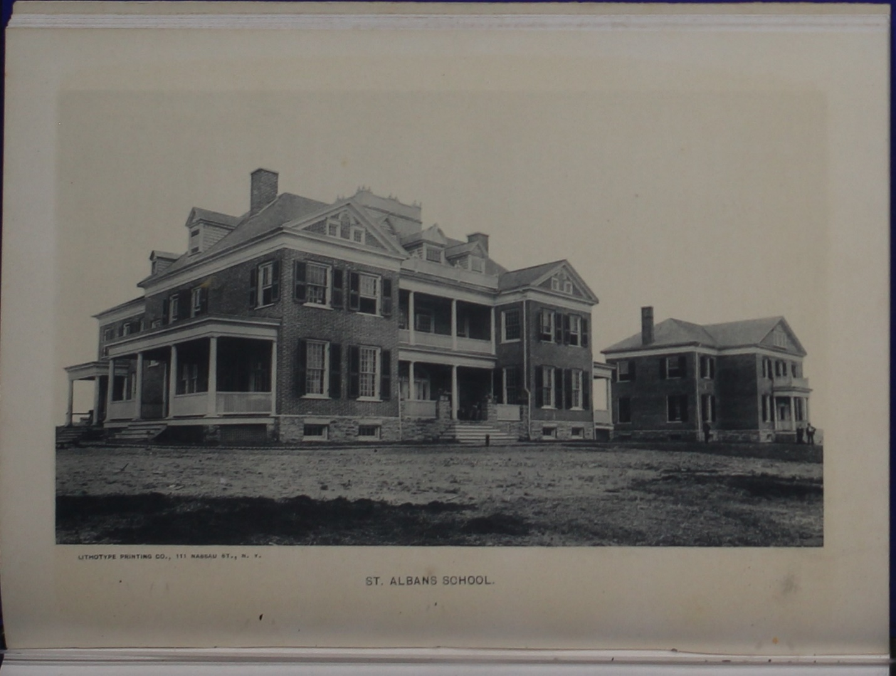

The school started out very successfully, but was fully closed in 1911. In 1915, the building was bought by Dr. J.C King who established the Saint Albans Sanatorium. A substantial addition to the mental hospital was made in 1980 and continued in operation until 2004. In 2001, Carilion Health System donated the St. Albans buildings to Radford University, pursuing a plan to construct an RU West campus there. In 2008, Radford University sold much of the property at auction. Paranormal investigators have flocked to the location since its closing to see if the site lives up to its name as the most haunted location on the east coast. Public tours of the building and grounds are available between April and September.

Much has been learned about this historic school through the yearbooks it left behind. Named the *Promus*, its chief aim was to present the athletic records of the school. Radford University has in its Special Collections volumes of the *Promus*for the years 1893-1904, excluding the year 1897-1898. These copies were donated by James P. King, M.D throughout the 1970’s. Presumably, Dr. King came across these issues of the *Promus* while serving as the medical director of St. Albans Sanatorium, which he retired from in 1976. There is also the assumption he may have inherited the property on the death of his father, the founder of the Sanatorium, Dr. J.C King.

The *Promus* included the headings of Personals (background of new students and faculty), As Others See Us (superlatives), Athletics, The *Promus* Entertainment (plays, musical and dramatic entertainments), and Ads. Various other headings are present and change from year to year.

St. Albans School quickly gained a reputation for being a rough and competitive school where bullying was encouraged. Many of the boys were “lost” during the years of operation. These “lost” boys are enshrined in the Promus with a picture and written snapshot of that boy’s character. One such boy, Irving Malone, is thus featured in the 1895-1896 issue of the *Promus*.

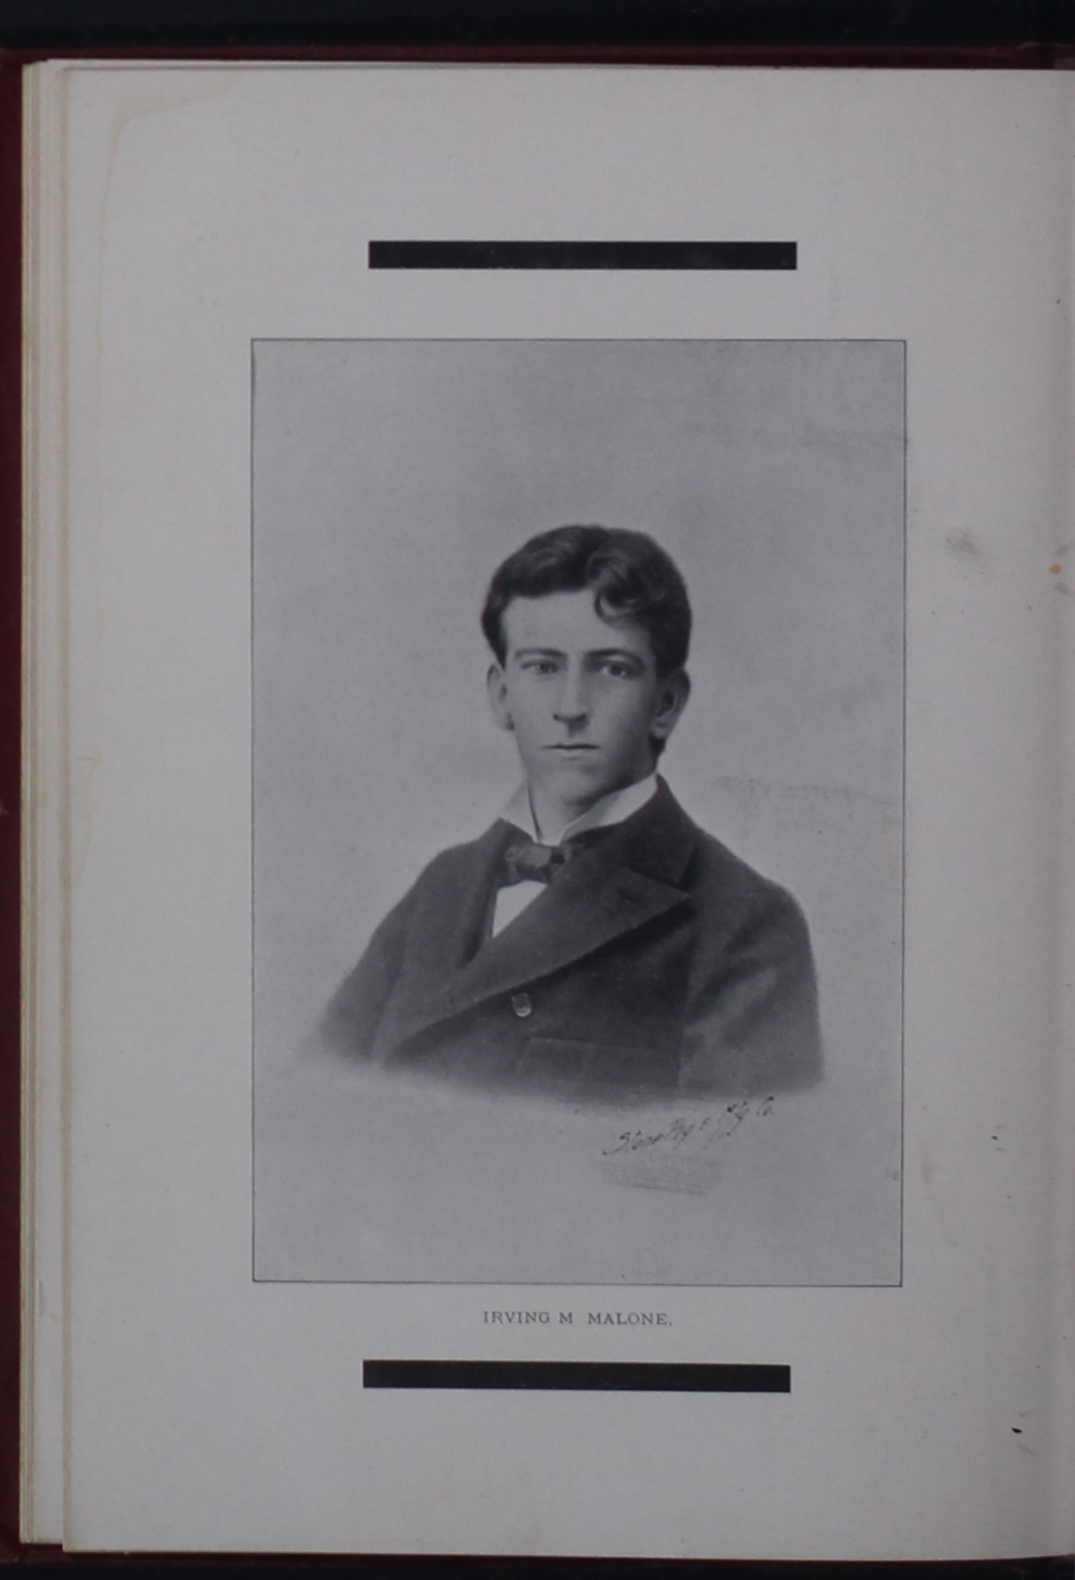

Despite the 113-124 year age difference between them and the boys of today, they still have a few things in common. The most obvious of course is sports. As can be seen in this picture taken from the 1898-1899 edition of the *Promus,* football and baseball were popular even then.

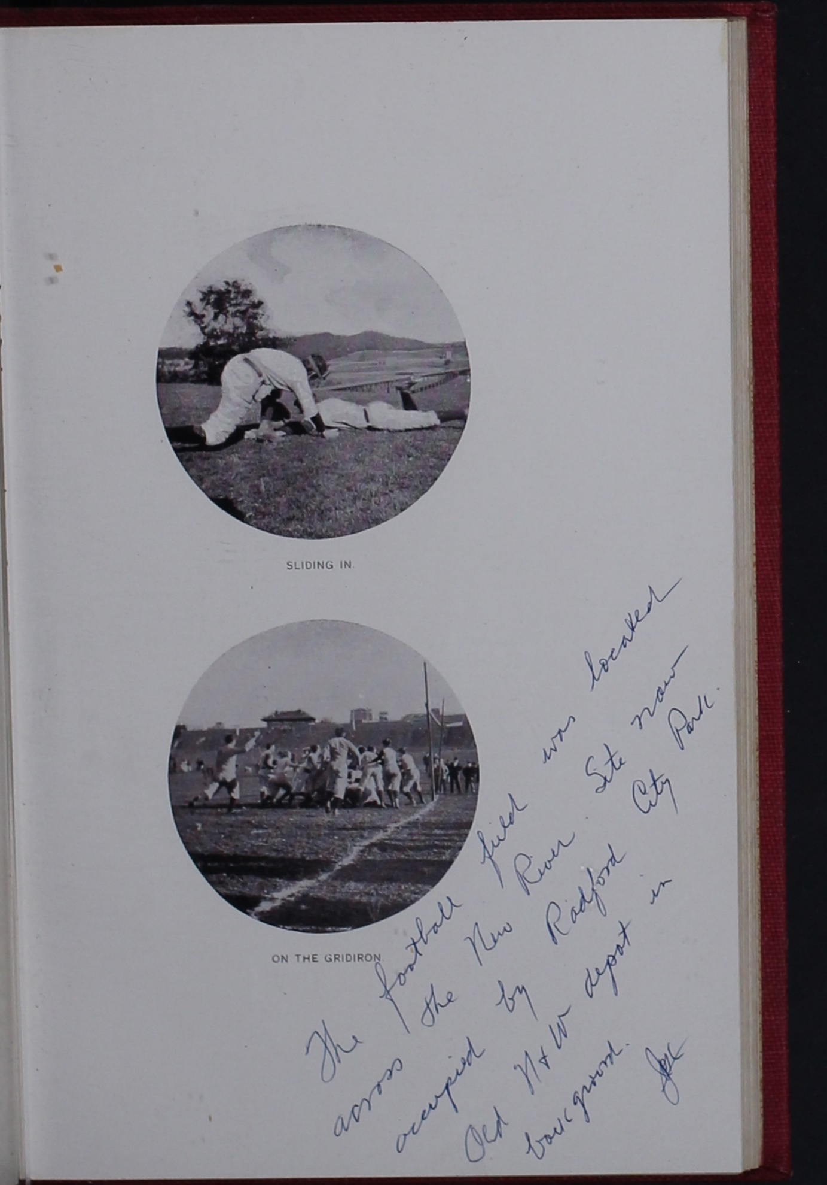

And of course, you can’t forget the girls……. Apparently boys in 1904 preferred brunettes!

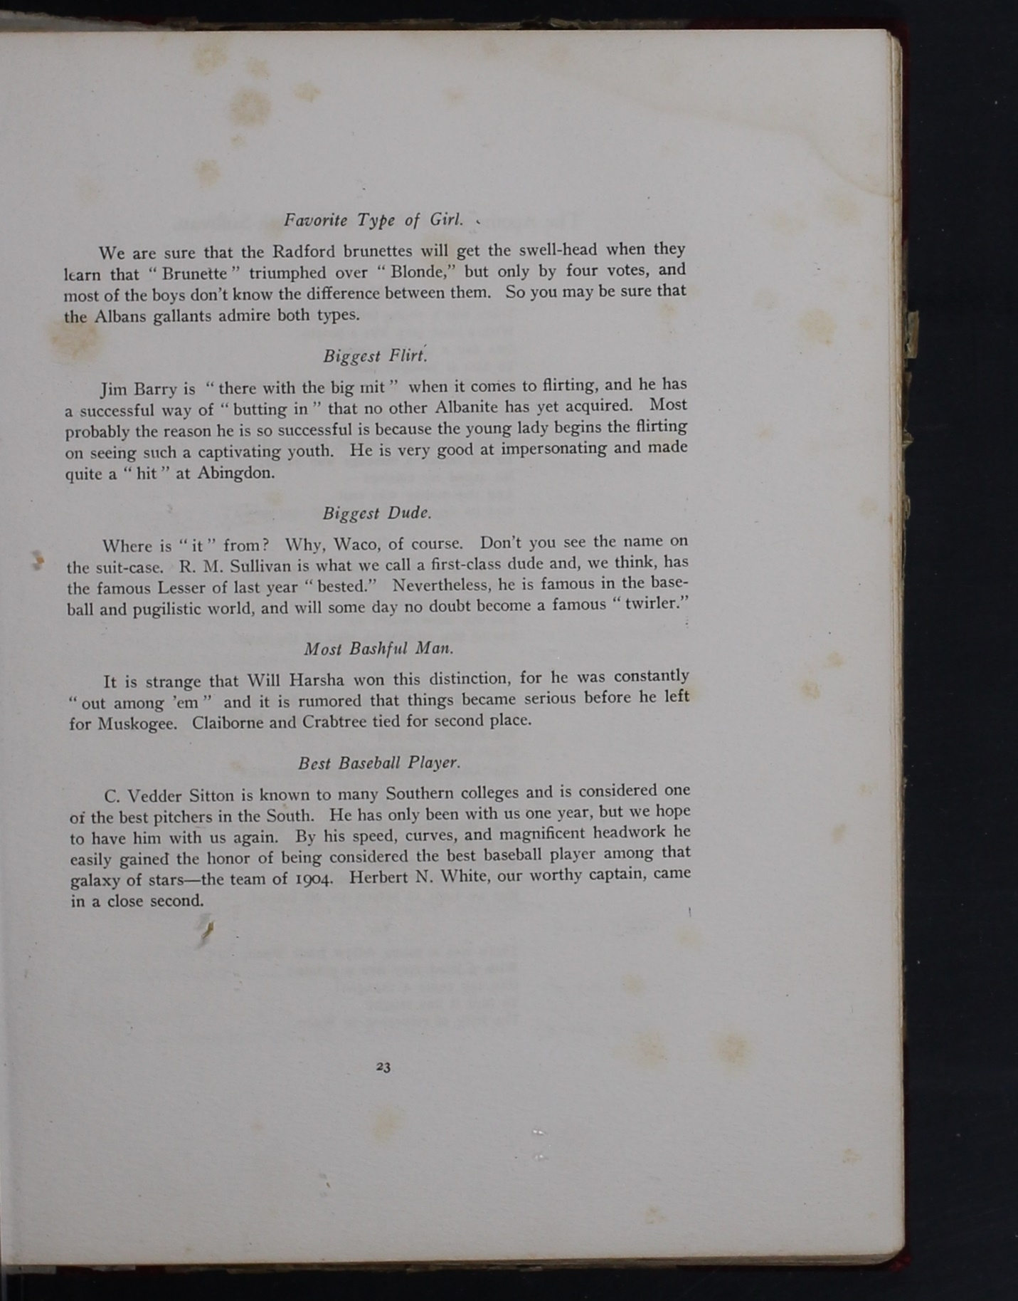

References

St. Albans School. (2014). Are you afraid of the golf? Retrieved from: [**https://roadtrippers.com/us/radford-va/points-of-interest/st-albans-sanatorium**](https://roadtrippers.com/us/radford-va/points-of-interest/st-albans-sanatorium)

What was There. St. Albans School/Sanatorium. Retrieved from: [**http://www.whatwasthere.com/browse.aspx#!/ll/37.1390113830566,-80.5801620483398/id/9608/info/details/zoom/14/**](http://www.whatwasthere.com/browse.aspx#!/ll/37.1390113830566,-80.5801620483398/id/9608/info/details/zoom/14/)

(1893, July 2) St. Albans School: It Ranks with the Best in America- A Few Points of Interest. *The Atlanta Constitution.*Retrieved from: [**https://www.newspapers.com/clip/1702272/st_albans_school_for_boys_george_w/**](https://www.newspapers.com/clip/1702272/st_albans_school_for_boys_george_w/)

SOURCE:

https://mozart.radford.edu/archives/index.php/2017/08/10/st-albans-school-and-the-promus/